MF
Faculty of Arts and Technology
Humberside University Campus
Kingston upon Hull
..........
enrolment number 008095880
.
.
.
.
.
..
.
.
.

.
.
.
.
.
.
.
.
.

CPG341 Programming in the Small

Assignment Number 1 Part II–Java Mastermind Game

Lecturer: Rose Spilberg

CPG341 Programming in the Small
.
.
.
.
.
.
..
.
.

Assignment Number 1 Part II–Java Mastermind Game
Contents
The Assignment Assessment Sheet 3
Requirements Brief for Part II 4
Class Hierarchy Diagram 5
Screen Shots 6
User Guide 7
Appendix A – Bibliography 8
Appendix B – Program Listing 9

The Assignment Assessment Sheet

Replace this page with the assessment sheet.

Requirements Brief for Part II

“Characterise an informal specification in terms of a requirements brief. Generalise and abstract specific systems requirements.”

Introduction
I am asked to design and implement a Graphical User Interface (GUI) version of the classic Mastermind (also known as pico-fermi, or Secret Code) board game, both as a Java application and an applet. For more information about Mastermind and Java applications vs. applets, see my User Guide on page 8.

Its user interface should be produced using our taught Abstract Windowing Toolkit (AWT) available in the first Java Development Kit (JDK) released in 1995, instead of Swing components, which can be used with either JDK 1.1 or the Java 2 platform. A Swing-based user interface is normally strongly encouraged, but is unnecessary here.

I am also asked to ensure that my program can be demonstrated on the University’s network.

Honest John’s Clipart Collection for Programming Assignments CD

Class Hierarchy Diagram

“Design documentation must include class hierarchy diagrams.”

My program, Launcher.java, works as both a Java Application and an Applet without modification. What follows is its class hierarchy diagram, for more comprehensive information see its Javadoc generated documentation later on:

Superclass
class Launcher extends Applet
Button newButton
Board frame
main, init, actionPerformed
class Board extends Frame
Peg peg[][]
inAnApplet, etc.
Board, paint, update, repaintPegs, mousePressed, etc.
class Peg
int color, x, y, radius
Peg, paint,
setPosition, setRadius,
setColor,
getColor
class MessageBox extends Dialog
Button okButton
MessageBox, actionPerformed

Fields
(state)
class members
Methods
(behaviour)

Subclasses

Screen Shots

“Submit screen dumps showing the program in operation.”

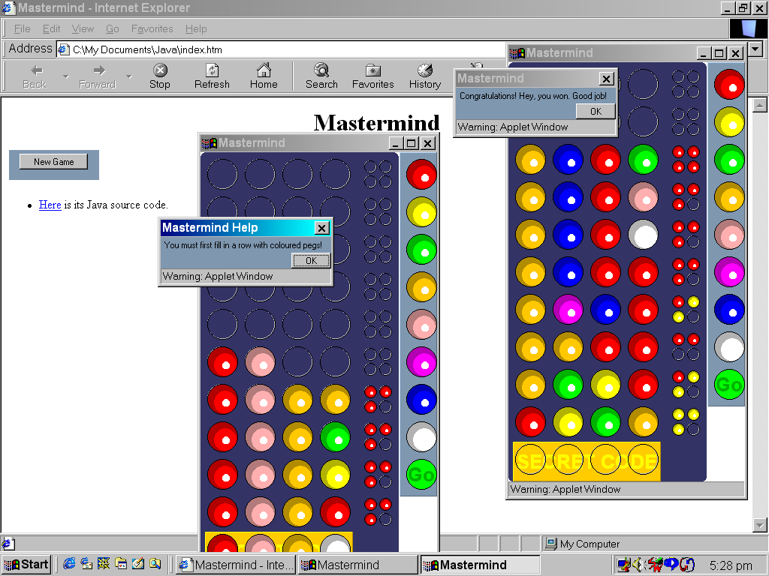

Figure. Oh No, More Windows! Running as Multiple Applets.

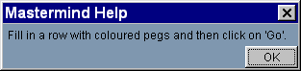
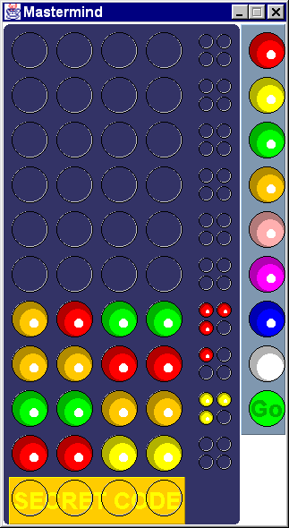

Figure. Running as an Application with a Dialog Window.

User Guide
“Design documentation must include user documentation.”

What follows is a guide to starting and quitting my program, which runs in a window as both an Application and an Applet. To quit my program, click the Close  button in the upper-right corner of its window. Each section begins with the difference between running Applications vs. Applets.

Starting an Applet
Applets are meant to be included in HTML pages. Either a Java-enabled Web browser or the appletviewer is required to run an applet.

To run, click on index.htm and then click the New Game button. Any opened games are quit individually.



Starting an Application
A Java application is a standalone Java program – a program written in the Java language that runs independently of any Web browser. A Java interpreter, such as the Java Runtime Environment (JRE) from Sun, is required to run an application.

To run, type the following at your shell (e.g. MS-DOS) prompt, then press Enter:

java Launcher

Playing Mastermind
The object of Mastermind is to guess the sequence of four coloured pegs that the computer has selected at random. You are given ten guesses to try to find the solution.

To make a guess fill in a row with coloured pegs from the peg selection panel on the right. If you are happy with your four pegs then click the Go button. After you click Go, the computer will award you one peg for each correct colour – red  if your guess was also in the right place (but you don’t know which peg), otherwise yellow  (again you don’t know which peg).

To reveal the computer’s secret code at any time click on the SECRET CODE.

Appendix A – Bibliography
“Where you use sources of information to help you, all the sources of information you use must be listed.”

Course Notes

Rose Spilberg, Lecture notes and PowerPoint slides for CPG111.

Internet and Online Articles

Java for C/C++ Programmers, An Audio/Visual Course, IBM ELS Knowledge Player.
http://www.ibm.com/java

The Java™ Tutorial, A practical guide for programmers, Sun Microsystems.
http://java.sun.com/tutorial

Java Mastermind Game by Sieuwert van Otterloo, lifted 8/5/01
http://www.students.cs.uu.nl/~smotterl/mmind

Introduction to Computer Science using Java by Bradley Kjell, lifted 2/5/01
http://chortle.ccsu.ctstateu.edu/cs151/cs151java.html

Computer Software

Word 97 for Windows 95/98 (1997). [Computer program]. Microsoft Corp.

Java™ 2 SDK, SE Version 1.3.0 for Win32 (2000). [Development Kit]. Sun Microsystems.

Notepad for Windows 95/98 (1997). [Plain text editor]. Microsoft Corp.

Appendix B – Program Listing

Replace this page with the program listing.

